**Introduction to DBMS #2**

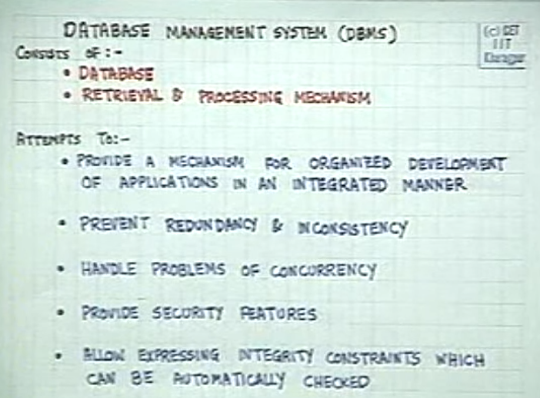

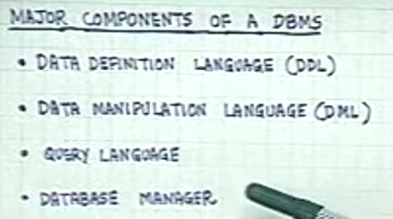

DML – this requires a compiler, the program is compiled and is converted into Application program object code.

**Query Language** –

* Subpart of DML, doesn’t require a compiler. Automatically process the data in the database.
* Usually procedural or non-procedural
* It must have a processor but doesn’t require a compiler.

**Overview of DBMS**

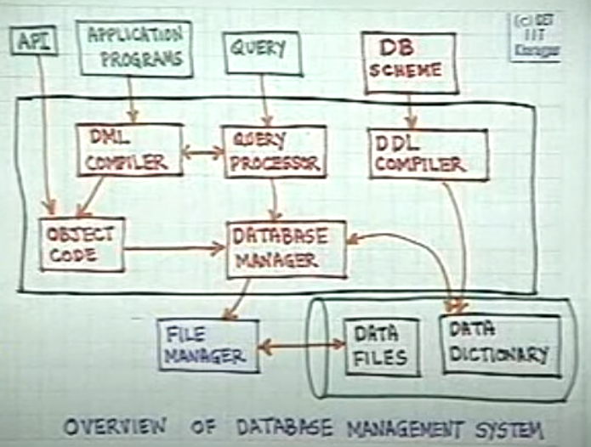

1. DB Schema will be stored in the Data Dictionary. – Data structures used, Data types of fields etc.
2. Data or the values will be stored in the Data Files
3. Application program is written in DML, they have to compiled. Once it’s compiled, as it’s a program, an object code will be generated.
4. Application program will use the data structures defined in the DB Scheme. This cannot be done directly, at the point of **object code** we are not aware about the format of the scheme, the data structures used, data type etc. therefore for many aspects of the code, especially for Read – Write of the Database , **object code** will consult the **Database Manager.**
5. **Database** manager will look up the Data Dict and then see what data(as per the query).
6. File manager returns the data to the Database manager.
7. Query are not required to be compiled always, they can retrieve the data directly via query processor. **DML compiler may sometime require Query Processor.**

**Data Models**

Before writing a program you need to have basic understanding, pseudo code, then you can put in to code. In database design also, we need to first conceptualize the DB or the scheme.

Data Models are tools to conceptually designing a Data Base.

